**How to install helix plus on your fusion 360**

1. Install python 3.X on your system.
2. Install the packages **numpy** and **Equation** by using the pip install command. (Do your own research on python if you’re not familiar, very advisable to use the pip install command)

Here are the links for the packages.

* 1. https://pypi.org/project/numpy/
  2. <https://pypi.org/project/Equation/>

1. Unzip the “HelixGenerator_advanced-master” folder you downloaded
2. Fix the path for the installed packages (**numpy** and **Equation**) in the code:
   1. open the file “Helix_Advance_Command.py”
   2. change the following directory to the correct directory where the python packages are installed on your computer:
   3. 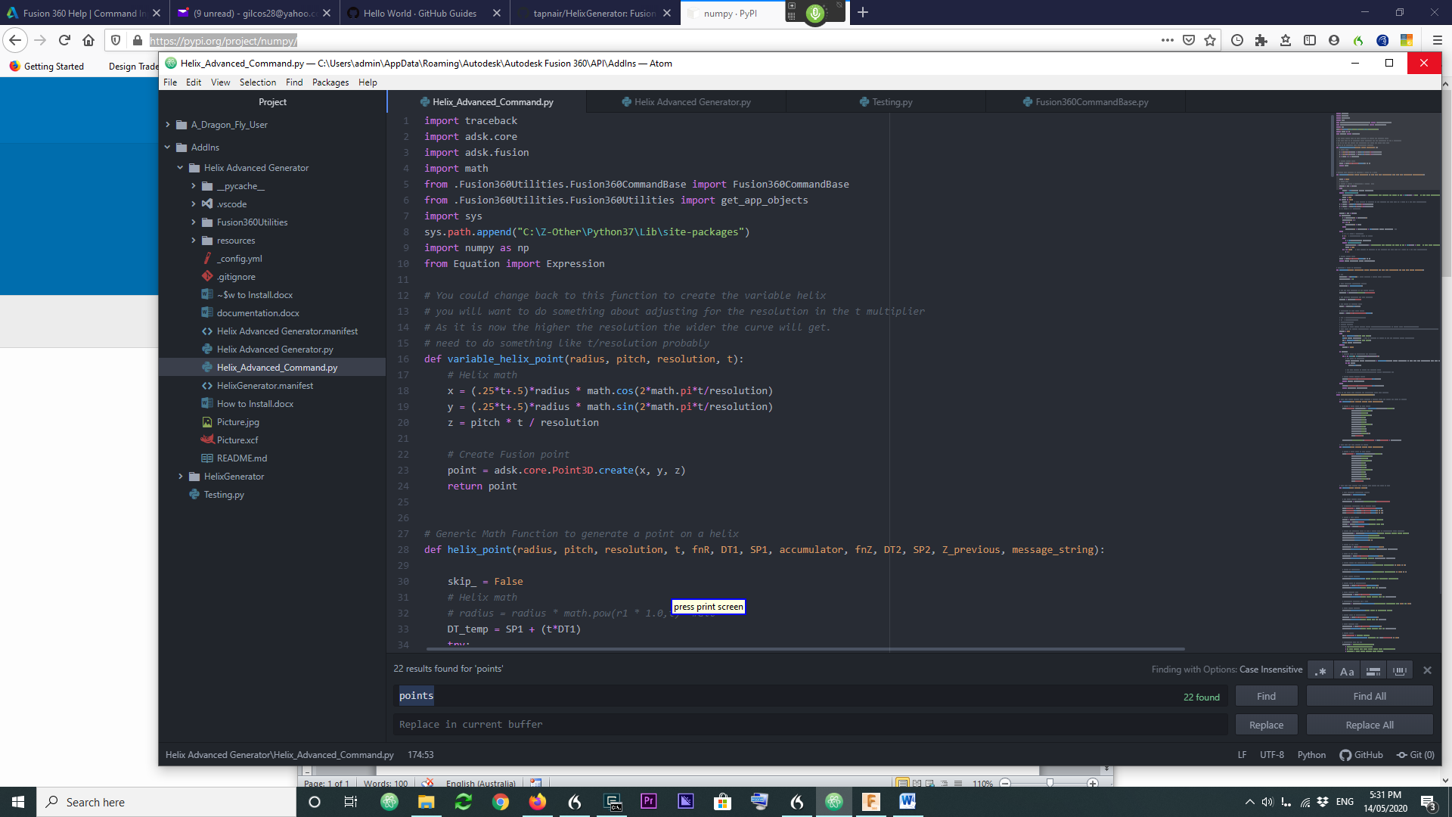
3. Go to next page
4. Install the Add-Ins by copying the whole directory of the “Helix Advance Generator” folder to the dedicated Add-Ins folder at Fusion 360:
   1. here is how to find the directory you’re supposed to copy the “HelixGenerator_advanced-master” folder. (Should be a bit different on your computer)

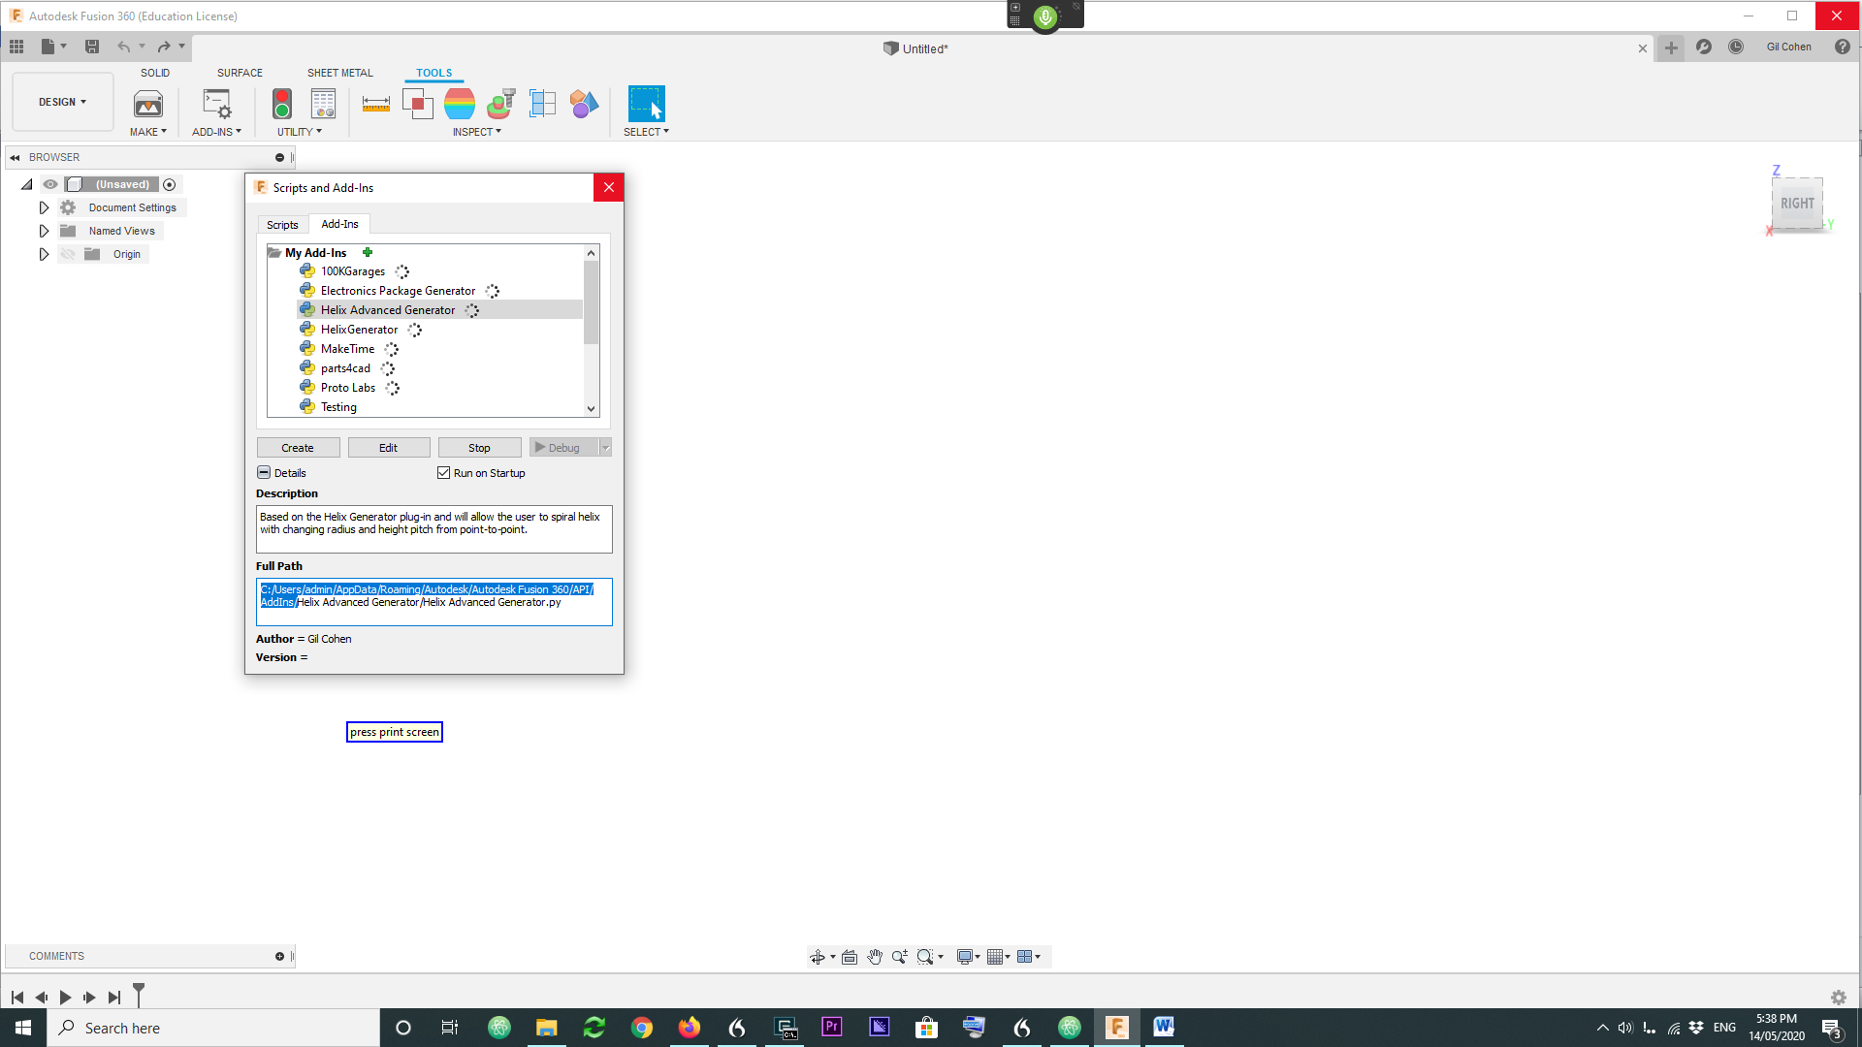

You can rename the folder name

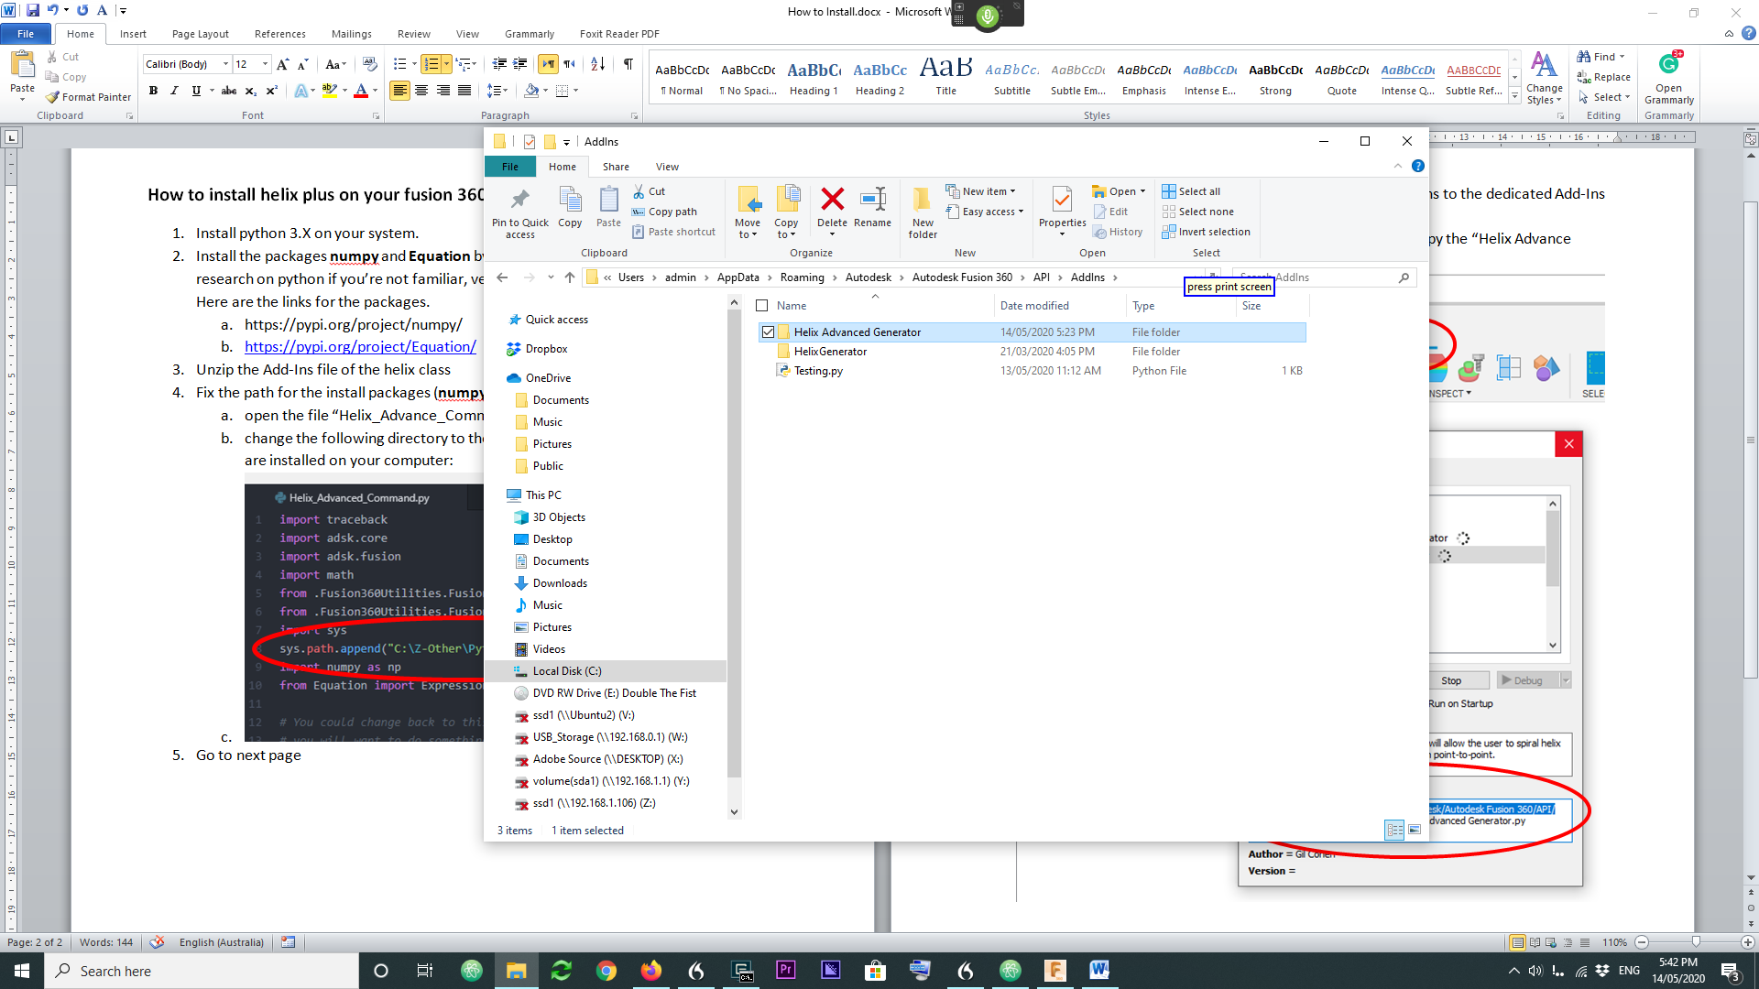

Now go back to Fusion 360 after you copy the folder and go into Add-Ins window as shown above in press “Run”, and “run on Startup”

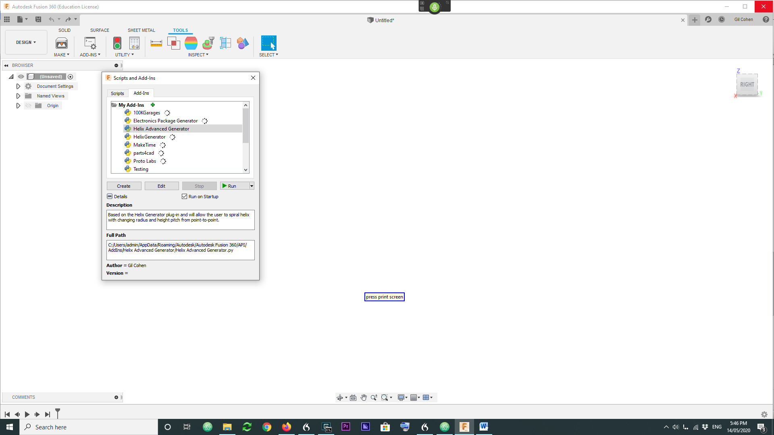

And you’re supposed to be ready to go

Just enter into a new sketch, and check the menu for “Helix Plus”

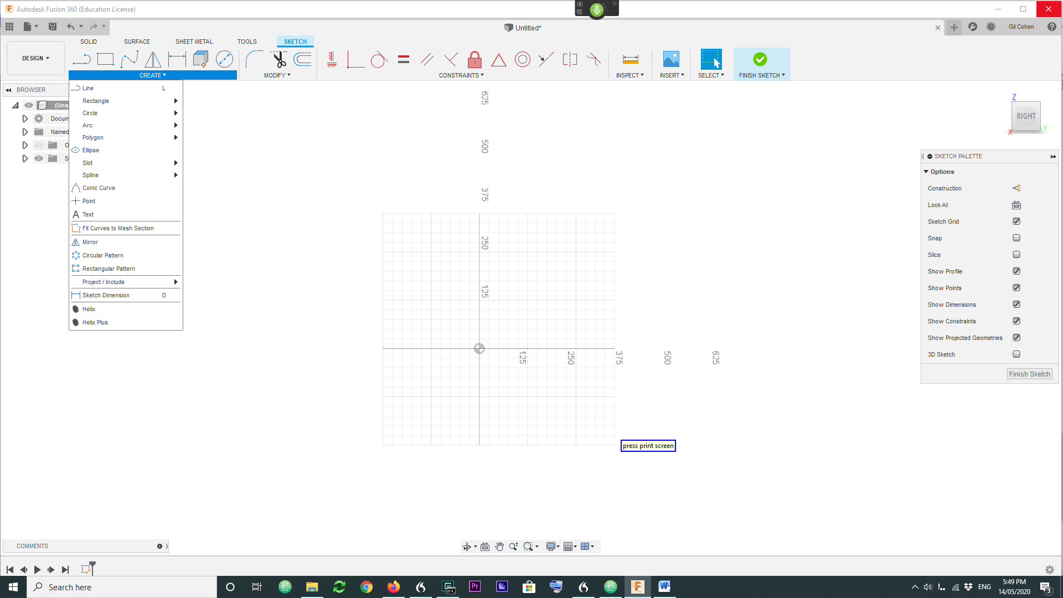

**Troubleshooting:**

1. The numpy version that works well is 1.19.3.

If the model doesn’t work, consider to downgrade the numpy to the above.

pip install --upgrade numpy== 1.19.3

1. This software was tested in python 3.7x.